Methods

We use the EPA Biosolids Annual Report (2022, downloaded on November 10, 2023) to obtain data on biosolids generation and management practices. The biosolids dataset includes facilities that produce biosolids beyond just municipal wastewater treatment plants, many of which may have nearly identical names to the facilities in our wastewater treatment plant inventory despite being separate facilities. However, the dataset lacks a common but unique facility identification number (such as CWNS number) to use to directly match a facility in the Biosolids Report to the facilities in our inventory. Thus, we first removed facilities listed in the Biosolids Report that likely were not wastewater treatment plants.

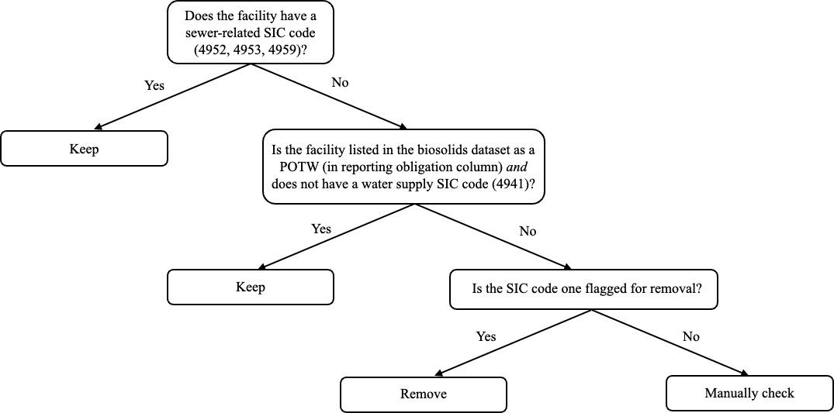

The workflow for filtering biosolid permits is depicted in Figure [X], and uses the SIC codes associated with each NPDES permit, obtained from the national SIC code database (downloaded on [DATE] from [NAME OF WEBSITE]). First, we kept all facilities that had SIC codes affiliated with sewer-systems (4952, 4953, and 4959). Next, we checked which facilities were listed as publicly owned treatment works (POTW) in the Reporting Obligation(s) column of biosolids report data. Because POTW may be either wastewater or drinking water facilities, we kept all facilities that were listed as POTW but did *not* also have a water supply SIC code (4941). Of the remaining facilities, we removed all facilities with SIC codes that make them unlikely to be municipally owned wastewater treatment facilities (listed in Table [X], descriptions from the NAICS & SIC Crosswalk). We keep all facilities that do not have an SIC code match. Following these automated filtering steps, we manually checked publicly available online information on the remaining facilities. There were five facilities that required manual checks, summarized in Table [Y], none of which were municipal wastewater treatment plants and thus were also removed from the dataset.

Table SIC codes associated with facilities in the biosolids dataset that were flagged for removal. A facility was removed from the Biosolids Dataset if it failed the first two exclusion criteria in Figure 1, and was associated with one of the SIC codes listed in this table.

|  |  |
| --- | --- |
| **SIC Code** | **Description** |
| 1389 | Oil & gas field services |
| 1522 | Residential construction |
| 2011 | Meat packing plants |
| 2491 | Wood preserving |
| 2493 | Reconstituted wood products |
| 2621 | Paper mills |
| 2899 | Chemical preparation (spice / food extraction) |
| 3171 | Handbags & purses |
| 3331 | Primary copper |
| 3498 | Fabricated pipe & fitting |
| 3533 | Oil and gas field machinery |
| 3743 | Railroad equipment |
| 4011 | Railroads |
| 4581 | Airports |
| 4911 | Electric services |
| 5075 | Heating & cooling |
| 5541 | Gas station services |
| 5812 | Eating places |
| 6514 | Dwelling operators (residential) |
| 6515 | Mobile homes |
| 6531 | Real estate agents & managers |
| 7011 | Hotels & motels |
| 7032 | Sporting and recreation camps |
| 7033 | Trailer parks / campsites |
| 7041 | Membership hotels |
| 7997 | Sports / recreation clubs |
| 7999 | Amusement and recreation |
| 8051 | Skilled nursing care |
| 8063 | Psychiatric hospitals |
| 8211 | Schools |
| 8221 | Colleges & universities |
| 8661 | Religious organizations |
| 9223 | Correctional facilities |
| 9711 | National security |

Table : List of facilities manually inspected for inclusion or exclusion from biosolids dataset. Note facility names appear as written in the downloaded EPA report.

|  |  |  |
| --- | --- | --- |
| **Facility Name** | **SIC Code & Description** | **Notes** |
| Live Oak County Safety Rest Area WWTF | 7299 (misc. personal services) | Rest area waste facility – not a municipal wastewater treatment facility |
| Bayou Club WWTP | 8641 (civic & social association) | Wastewater treatment at a club – not a municipal wastewater treatment facility |
| GE Packaged Power Jport | 3511 (turbines / turbine generators), 7699 (repair services) | General Electric is a private company – not municipal wastewater treatment facility |
| Sigmapro WWTP | 6519 (real property lessors) | Sigma Pro is a private company - not municipal wastewater treatment facility |
| US DOE / Savannah River Site | 2819 (industrial inorganic chemicals), 9611(administration of general economic programs) | US Department of Energy facility – not a municipal wastewater treatment plant |